1. **CMPE 240 Experiment 6 Preliminary Work**

We have used multi bit cables. X= x4x3x2x1x0 Y=y4y3y2y1y0 meaning Y[3:1]=00y3y2y1

Muxes inputs used as 11 10 01 00 meaning least significant bit is at right. Select inputs used as s0  
 s1  
meaning least significant bit Is at top.

5 bit adder is like this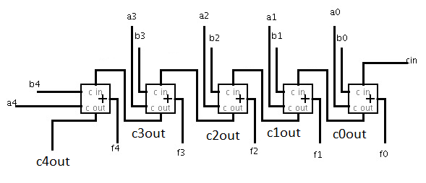

Step 1: Design circuits with minimum number of components for each function of the

ALU (This section should consist four circuits for each functionality of ALU) Show internal representation of each component as well. For example if you are using a full adder, draw inside of it as well. If you are using a component more than once, it is enough to draw inside of it once. You can represent repeated ones as black boxes providing their input/output labels clearly.

1. S=00

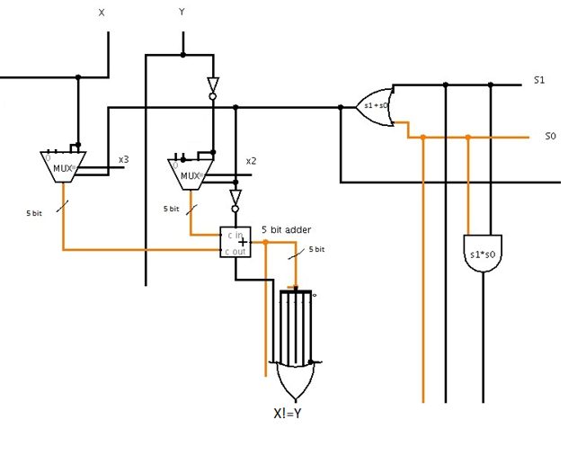

This part calculates X-Y and ors it. İf X=Y output is 0. İf X!=Y output is 1.

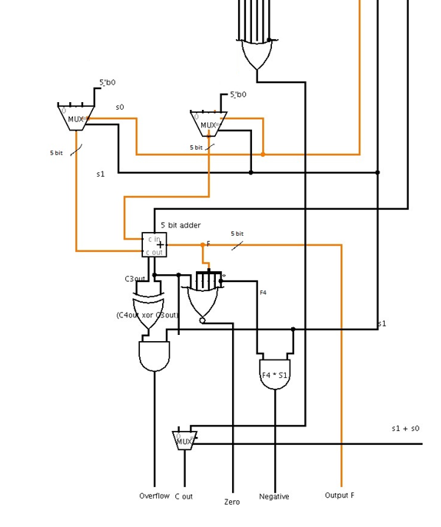

This part gives output IA and IB and ICin as zero. Outputs F as 0, Cout as X!=Y, negative and overflow as 0 zero as 1.

b)S=01

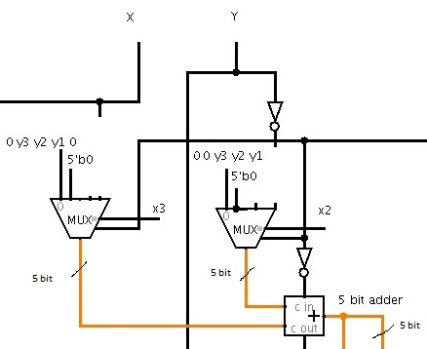

This part calculates multipleres 2 first term according to x2 and x3 and adds them.

Gives output as IB

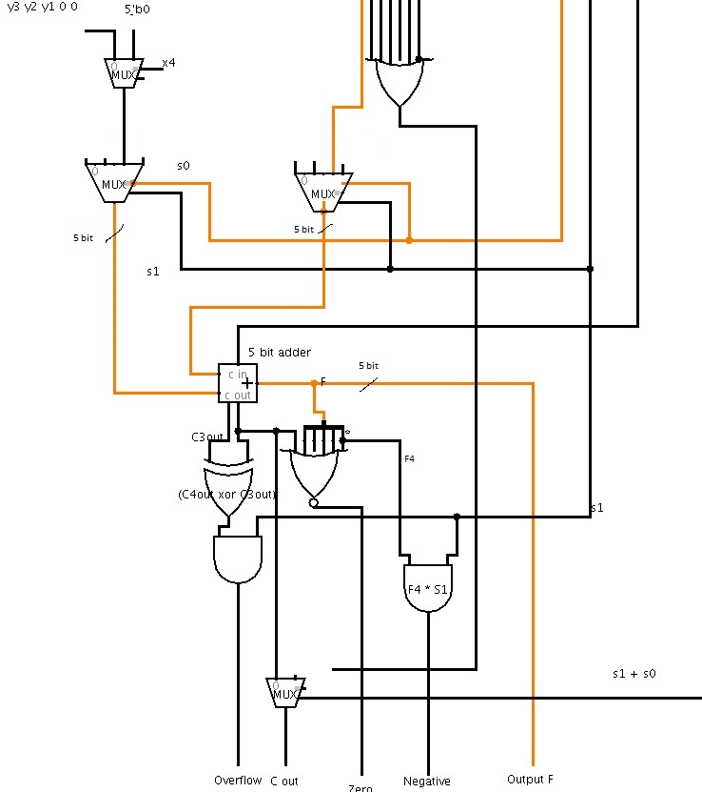

This part gives IA as multipliers last term. 0 if x4 is 0. y3y2y100 if x4 is 1. Gives Cin as 0.

Outputs negative and overflow as 0.

c)S=10

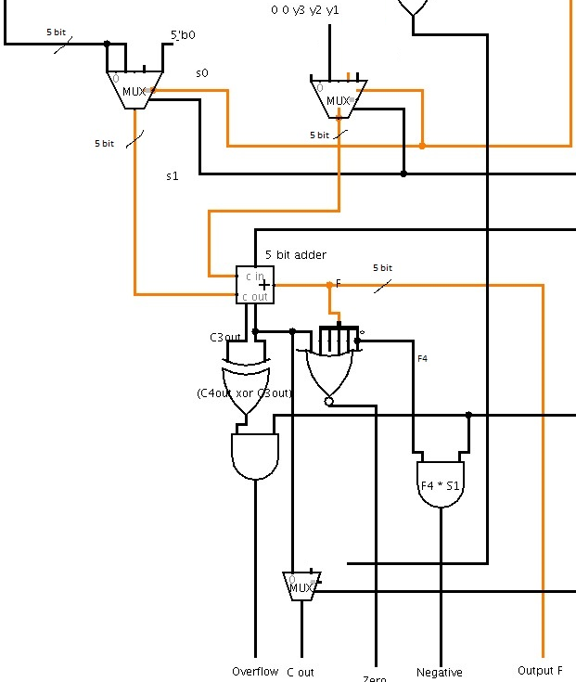

This part gives X and Y[3:0]/2 as IA and IB, gives Cin as 0. Outputs outputs accordingly.

d)S=11

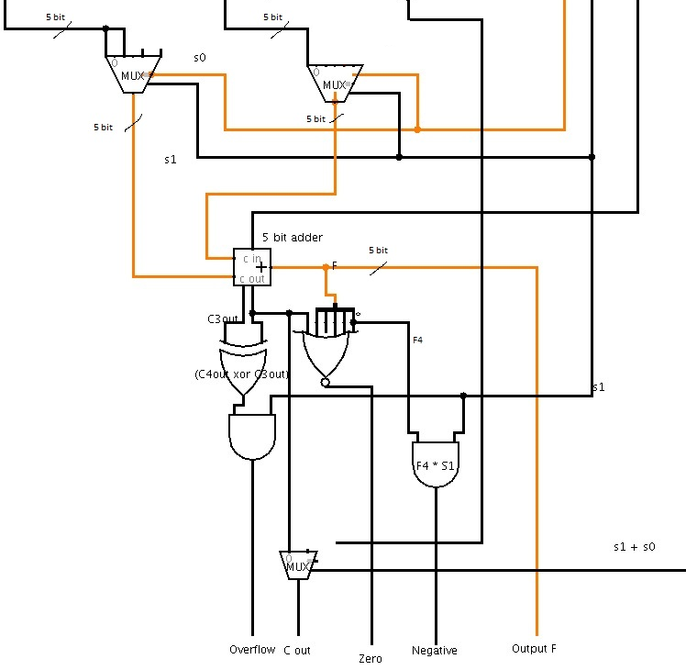

This part gives X and Y as IA, IB, Cin as 1. Outputs outputs accordingly.

Overflow: İf s1 is 0 outputs overflow as 0. İf not overflow is c3out xor c4out. From last 5bit adder.

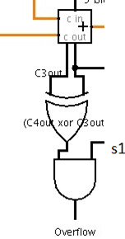

Cout: if S=00 outputs as X!=Y (it is calculated ad top 5 bit adder, explained in S=00 case)

Else it outputs c4out from last 5 bit adder.

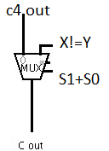

Zero:İf c4out,f0,f1,f2,f3,f4 are all zero outputs 1. Else outputs 0.

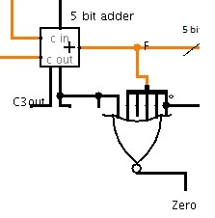

Negative: Outputs f4*s1. İf s1 is 0 outputs 0. Else outputs f4.

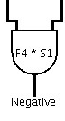

Output F: Outputs output of the last 5 bit adder.

Step 2: Merge all operations with select inputs and organize outputs, Try to minimize your implementation by using repetitions, draw final circuit as the minimized final design of the ALU.

